FLOOD MONITORING SYSTEM

PHASE -5

1. *Sensor Network*: Display a network of flood sensors in flood-prone areas to collect data on water levels, rainfall, and weather conditions.

2. *Data Collection and Transmission*: Use IoT technology to gather data from the sensors and transmit it to a central server or cloud platform in real-time.

3. *Data Storage*: Store the collected data in a reliable database to ensure historical records are available for analysis and future reference.

4. *Data Analysis*: Implement data analysis algorithms to process the collected data for flood risk assessment, early warning, and trend analysis.

5. *Early Warning System*: Develop a mechanism to alert authorities and the public when flood risks are detected, using methods such as SMS, mobile apps, or sirens.

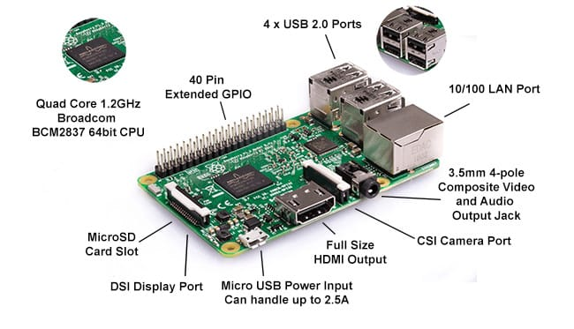

6. *Geospatial Mapping*: Incorporate geospatial data to provide accurate location-specific flood information, including floodplain mapping.

7. *Integration with Weather Data*: Integrate weather forecasting data to enhance flood prediction and preparedness.

8. *Code Implementation*: Implementing a flood warning system involves multiple components, such as data collection, analysis, and alerting. Below is a simplified example of how you might implement a basic flood warning system in Python. A real flood warning system would require more complex data sources and analysis.

Python code:

import time

import random

import requests

# Simulated flood sensor function

def read_sensor_data():

return random.uniform(0.0, 10.0) # Simulated water level (in meters)

# Function to log sensor data to a file

def log_sensor_data(sensor_data):

with open("sensor_data.log", "a") as file:

timestamp = time.strftime("%Y-%m-%d %H:%M:%S")

file.write(f"{timestamp} - Water Level: {sensor_data} meters\n")

# Function to send alerts

def send_alert(alert_message):

# Replace this with actual alerting mechanisms (e.g., SMS, email, or sirens)

print(f"ALERT: {alert_message}")

# Main monitoring loop

while True:

sensor_data = read_sensor_data()

log_sensor_data(sensor_data)

print(f"Current water level: {sensor_data} meters")

# Define a custom threshold for triggering an alert

alert_threshold = 7.0

if sensor_data > alert_threshold:

alert_message = f"High water level detected: {sensor_data} meters. Alert threshold: {alert_threshold} meters"

send_alert(alert_message)

time.sleep(60)

9. *Data Security*: Implement strong data security measures to protect sensitive information and prevent tampering.

10. *Collaboration*: Collaborate with local authorities, meteorological agencies, and other stakeholders to ensure the project's success.

Conclusion:

A flood monitoring system using sensors is a vital technological solution for mitigating the devastating impacts of floods. This project aims to provide early warning, data collection, and analysis, ensuring that communities and authorities can take timely action to minimize flood-related risks.

Created by:

Adithya G.S

Mohan G

Muthuselvan J

Iyappan A

Harish Prashad R